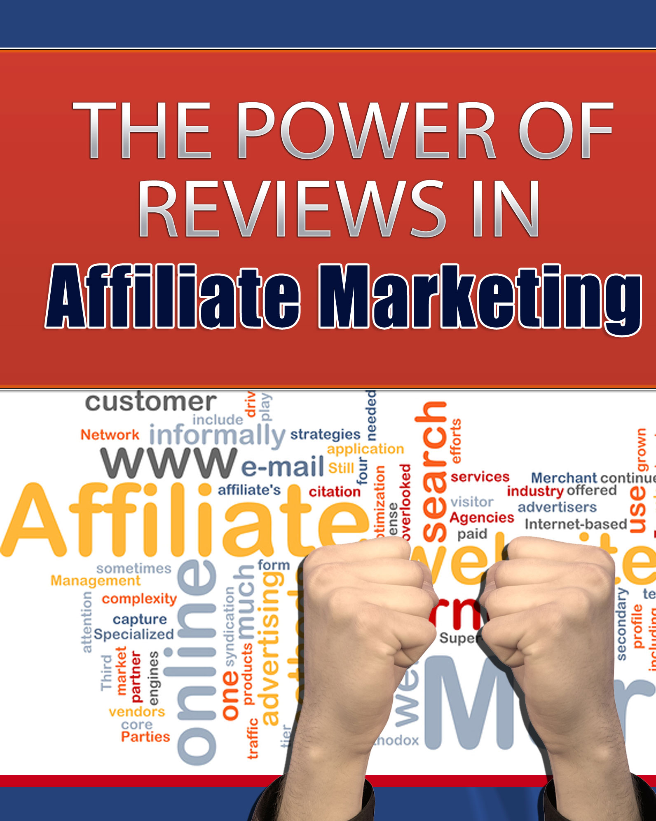

The Power of Reviews in Affiliate Marketing

Reviews are said to be the most important component of affiliate marketing. There are some subtle and not-so-subtle reasons for that.
- People like to feel you’re in their “corner”. When an affiliate marketer takes the time to nurture the members of her niche, solve their problems and look out for their interests, each member comes to trust the person who does good things for them – and consistently helps them succeed.
How do you do all these good things?
By finding them exactly the product they need to solve this week’s problem or enhance their lives (or even just their hobby). You do this by focusing on their problem, not on the product. Strange as this may sound.
After you’ve showed them the pros and cons of a product, directing them to your affiliate link should feel as if it’s almost an afterthought, or – even better – as helpfully supplying the exact way to do what you’ve just been talking about.
- People don’t like being “sold” to. Nobody likes to be manipulated, and that’s what the old-school style of aggressive selling amounts to, in most people’s minds today. When you’ve shared a secret method of making money with your reader, it should feel as if you’ve truly shared a secret method, and helped them in the process.
This level of service is what online readers demand nowadays. Yes, “in your face” selling still works – but at the cost of your credibility, if your skills aren’t quite at the level of Billy Mays or Anthony Sullivan. You’re seen as the next best thing to a carnival hawker; and while these people do a unique and mesmerizing job and that comment is not meant to judge them, there’s a reason most of them end their days as carnival hawkers, still living on a shoestring; and not living next door to another celebrity or otherwise enjoying their particular dream lifestyle.
But there’s another, far simpler reason to avoid “hard sell” techniques, and it has nothing to do with your customers: Most affiliate marketers just don’t have the “hard sell” personality. They don’t enjoy manipulating and pushing people into buying. They actually enjoy finding products people rave about. And all of us love a good paycheck – one that allows us to comfortably live the lifestyle we’ve chosen, taking care of people we love. Writing reviews is a perfect way to:
- Recommend products you’ve tried that really work
- Show people how to solve a problem
- Make a connection, and enjoy a relationship with your readers
In fact, affiliate review blogging embodies this softer sell, service-based method of selling – as well as helping you comfortably maintain your integrity and ethics.

Crystal’s Secret
Years ago, I had an opportunity to watch a friend at work in a “tack” (equestrian supplies) store. This happened on a busy Saturday, and it was a revelation to see how patiently and helpfully she matched customers and their horses with the right saddles and bridles. By patient questioning and listening, she focused on the areas of horsemanship each customer indulged in, taking into account their budget, and what would give them the best performance and comfort for their needs. She repeated the same focused, patient procedure for Western boots, specialty horse feed, hoof products, supplements, riding apparel, hoof picks and English safety-approved helmets, too. No product was too “small potatoes”, if it would help her customer and his horse enjoy a better equine experience.
It was clear that my normally-shy, horse-loving friend, Crystal, was having an absolute blast – but there wasn’t a shred of ego in it. She was not “showing off” her knowledge; all her efforts were 100% customer-focused.
During a rare lull, I couldn’t help commenting: “Crystal, I thought you absolutely hated selling. I remember you trying to sell those vacuum cleaners, and quitting in tears, less than a week into it. You swore then you’d never sell anything again – and here you are today, you’ve made over $6,000 in sales, right before my eyes, in less than a morning. I’m stunned at how well you do it, and how much you seem to enjoy it. You’ve got those customers avoiding the other two girls, lining up to wait just for you. They’re eating out of your hand.”

I’ll never forget how surprised Crystal looked.
“But this isn’t `selling’,” she blurted out. “I’m helping them.”
And that’s how I’ve approached my own marketing, since, with every customer or client.
(It’s a fun way to live!)

But Does It Really Make You More Money?
That is the million-dollar question. But think about it… how many vacuum cleaners would you sell, if you hated every moment knocking on doors? You’d procrastinate, chicken out, and present a miserable, half-hearted sales spiel (just as Crystal did) when someone did finally, grudgingly let you inside.
I also remember vividly that she didn’t sell one single vacuum cleaner. That type of approach just didn’t gel with her personality – or interests.
You have to have a particular mindset to be an in-your-face, aggressive salesman. Most of us aren’t hard-wired that way. And that’s the beauty of review blogging…
It doesn’t matter what your favorite topic is, or whether you like to review products via podcast, presenting yourself on video, or by writing. It doesn’t matter whether you’re in the business of internet marketing, insurance, electronics or any other specialty niche: Reviewing products your niche will find valuable is a made-to-succeed formula for anyone.
You’re dealing with passionate people, when you’re dealing with a niche. Help them find exactly what they need, and in their eyes, you’re already a celebrity.

Is It a Lot of Work?
Affiliate review blogging is something you can do full-time, or part-time. It doesn’t take long to reach authority status, particularly once top marketers or professionals in a niche notice that your reviews bring them sales – and list members notice you always bring them good advice.
In fact, you really can work relatively short hours a day, once you’ve got your methods down pat, and no longer have to look up how to set up a WordPress blog or how to create an affiliate link redirect.
You can spend as much or as little time you like in promoting and driving traffic to those blogs, too – but you can do it in a way that fits in with your lifestyle and personality preferences.
If you hate making videos, you don’t have to. If you’ve got no time for Facebook, work from Twitter. If the whole social marketing scene drives you insane, focus your efforts on press releases and article marketing instead (and you don’t have to spend more time at these than you would on review writing, either, to achieve solid success).

JV’s and Super Affiliates
You may have heard of the power of JV (joint venture) reviews. This is when someone writes and asks if they can send a copy of their product to a “super affiliate” – someone who is one of the most prominent figures in their niche. If the super affiliate says “yes”, and actually produces a favorable review of the product, it can vault marketers overnight from “unknown” status to heading firmly for the top.
Less is said of the reverse phenomenon – instead of sitting there waiting until you’ve become a super affiliate before top marketers approach you with first “dibs” on their products, approach them yourself, and ask if you can be the first to review their next product. (Make it clear you expect to purchase the product, of course.)
You probably won’t hear back from most of them: Don’t take it personally. Just remember most of the top guns don’t even read their own emails – they have VA’s to do that who apply a certain, impersonal set of criteria to what gets responded to. (And there may even be no time to answer all letters, if their lists are especially gargantuan.)
But eventually, one of them may actually say, “Sure, I’ve got this new product, and you can test drive it for me.” You’ll then have an “exclusive” to share with your list – ahead of the herd!
It may comfort you to know that the whole key to getting a “yes” answer doesn’t lie in what a celebrity you are (or aren’t) but in whether or not your review blog is a good fit for their list.
When a top professional in your field says “yes”, and sends you that product ahead of the rest of the pack of review bloggers, that’s your time to show how many sales you can generate for them. (In the meantime, it goes without saying that you have already purchased and reviewed their existing products anyway.)
Who do you approach first?
Simple. The people you’ve already made the most sales for.
If this sales amount is substantial, they will probably know who you are. If it isn’t, spell it out for them. Tell them you’ve been in business X number of months (or weeks… or days) and that one review you did of their Product #65 generated you X amount of commission. Tell them you’d like to help promote their products more, and suggest that reviewing the next one straight out of the gap will help both of you reach your goals.
I should stop and stress here, you’re not soliciting freebies – make very sure your approach doesn’t contain even a whiff of that headspace. You’re letting them know you are available to review and promote their products… because their products are perfect for your list.
Surprised by that “yes” answer? Don’t be. Top marketers are all aware of the power of affiliate review blogs.
Just keep these key points in mind, and yours will become one of the sought-after sites sooner than you may be imagining.
Here’s how to help propel yourself more quickly towards success:
- Follow a “formula” (template), to give your reviews consistency and a distinctive style. (People psychologically love and align themselves to repetitive patterns.) And if you don’t have a formula or template – create one, and stick to it for each review
- Listen to your readers (or your niche market, if you’re brand new). Find out which problems haven’t yet been solved, and do your best to solve them by finding the right products – and telling they why it’s right for their needs.
- Present yourself intelligently. Study top affiliates, and see what little signature tricks or quirks they employ that set them above the “herd”. While all the other would-be review bloggers are buying book after book, all telling them to do the same things, over and over, spend your time studying the super affiliate reviewers and their sites – to see what they do differently. (Hint: Lynn Terry always includes a graphic signature at the end of her post and a P.S.)
- Always focus on your readers. This can’t be said too many times. Remember, no one is really interested in your expert opinion, even while they’re wanting you to be that expert. They’re too busy focusing on “Is this going to show me how to do X at last?”
- Don’t be afraid to be unique, and let people know who you are. Both you and your readers will have more fun – and the sales you attract will be less likely to generate refunds, because they’ll be more in line with your market’s real needs.
Happy and prosperous affiliate review blogging!

